Replication:

1. Created an account
2. Initiated an auto submission
3. Verified the census tract both in policy info screen and vehicle screen.
4. Quoted and bound the transaction.
5. Initiated a policy change and changed the address to new address in policy info screen.
6. Verified that even garage address got updated to new address.
7. Quoted the transaction and withdrawn it.
8. Verified that submission census tract did not get changed to new census tract or not.
9. Initiated one more policy change and verified that census tract got changed or not.

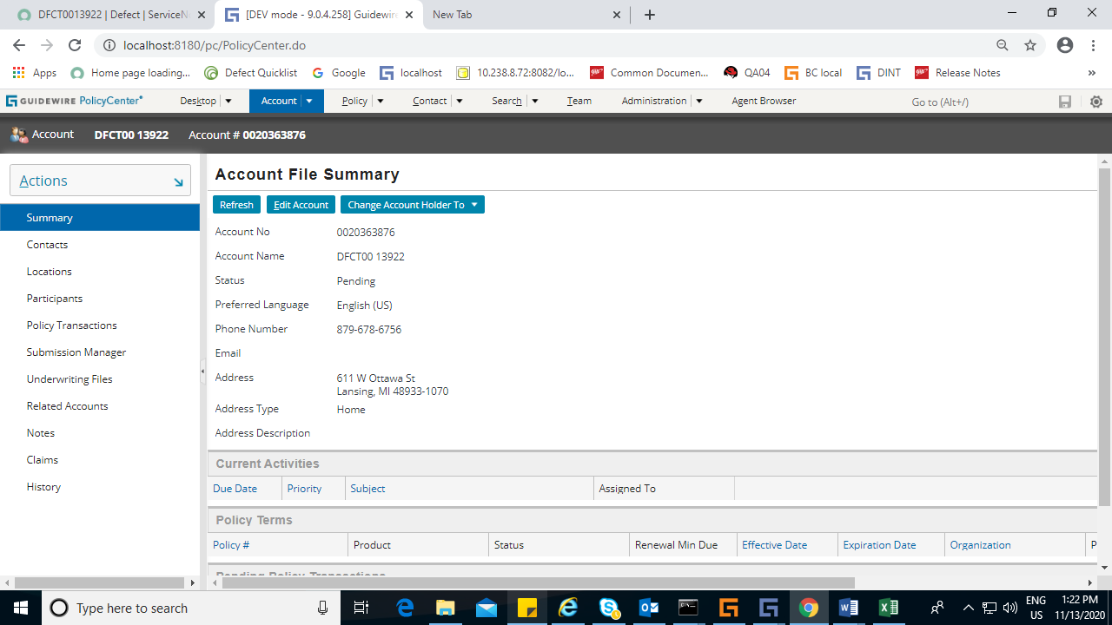

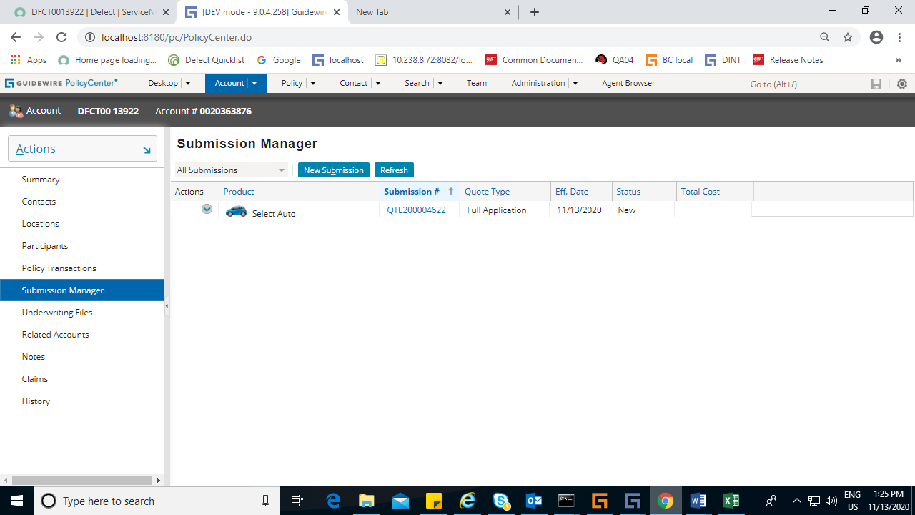

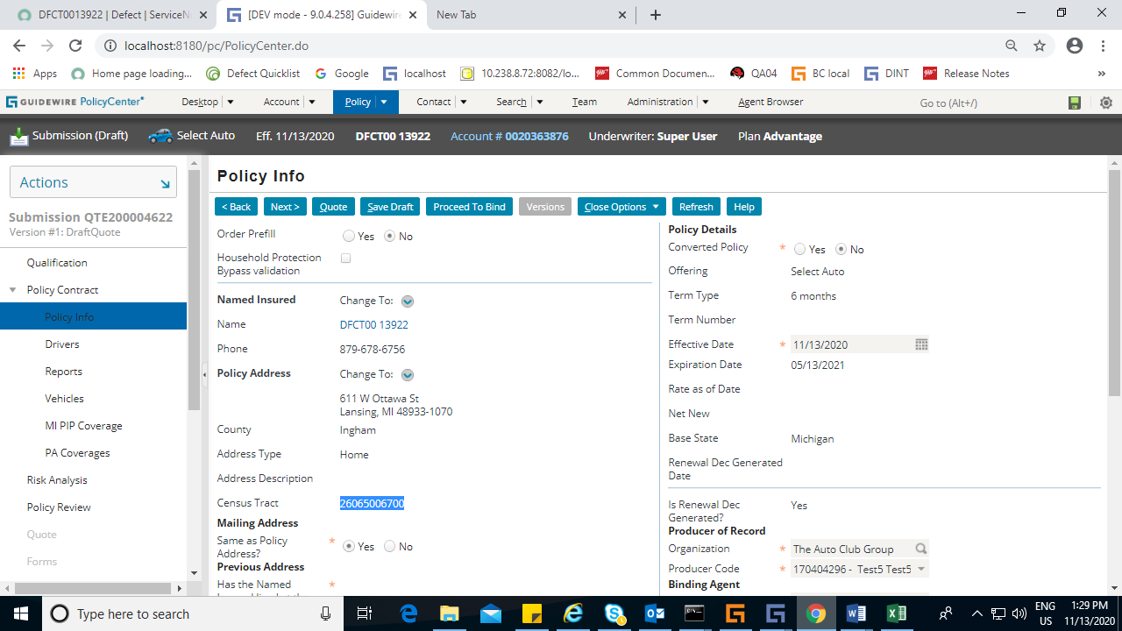

Vehicle screen

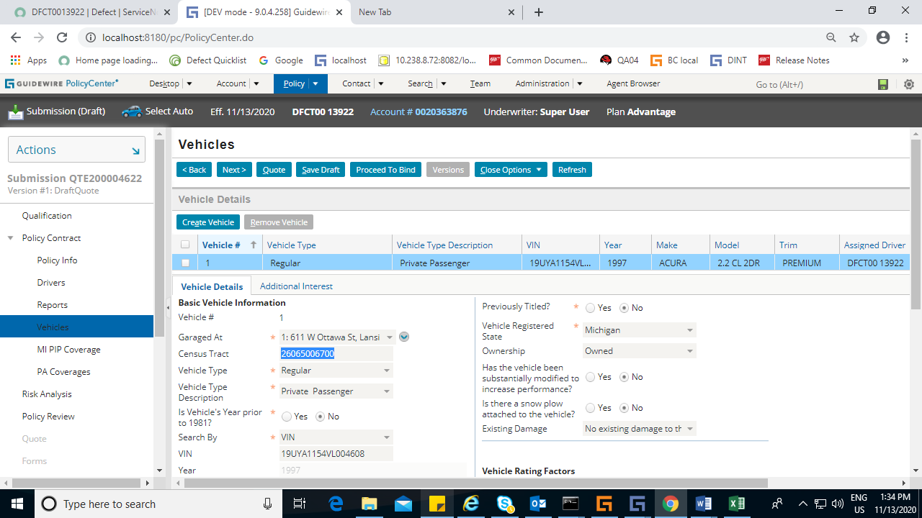

Quoted the transaction

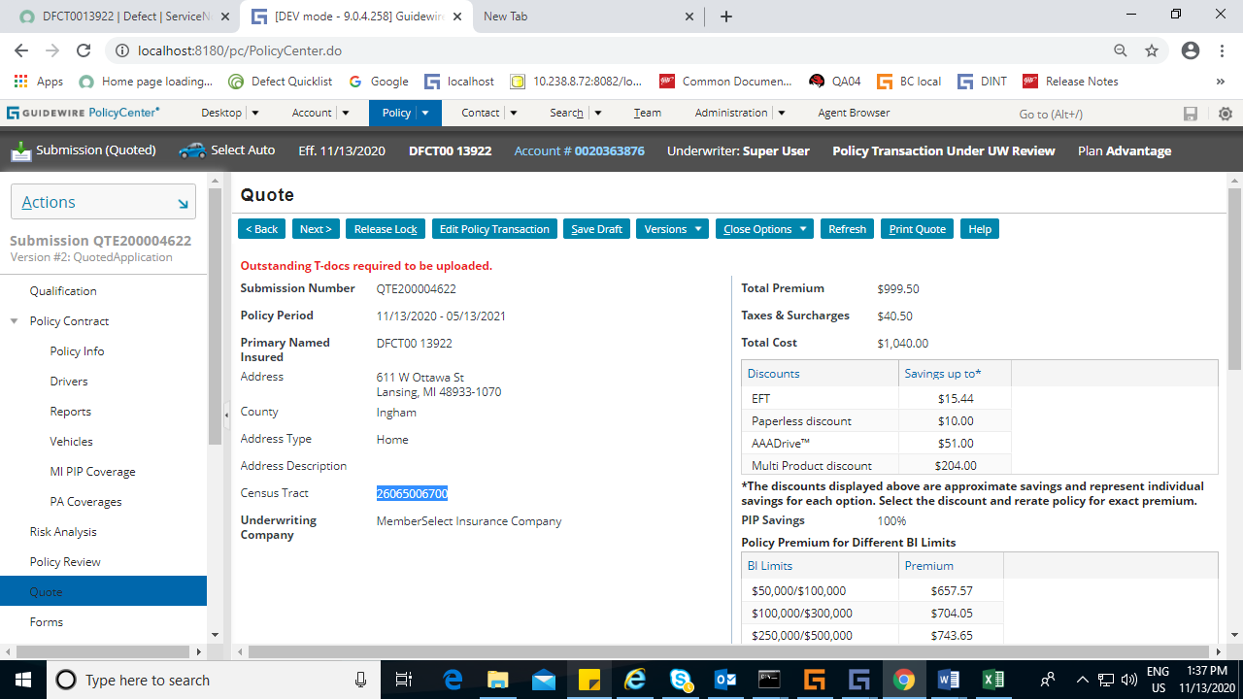

Bound the submission

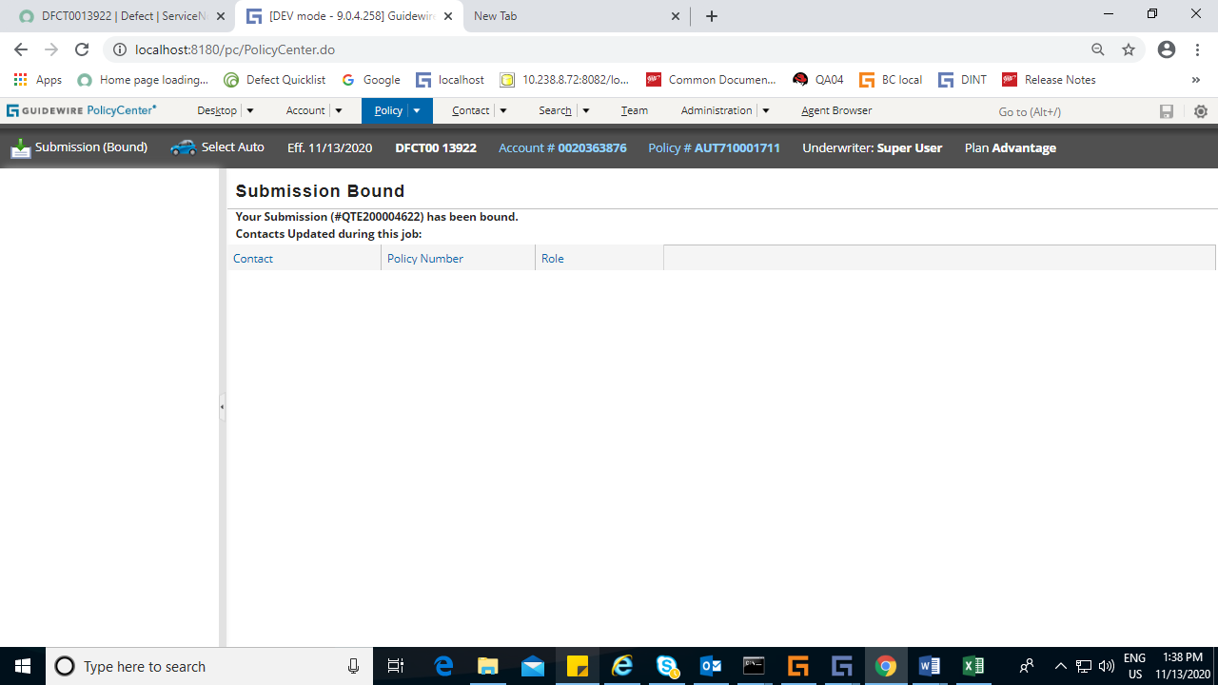

Initiated a policy change

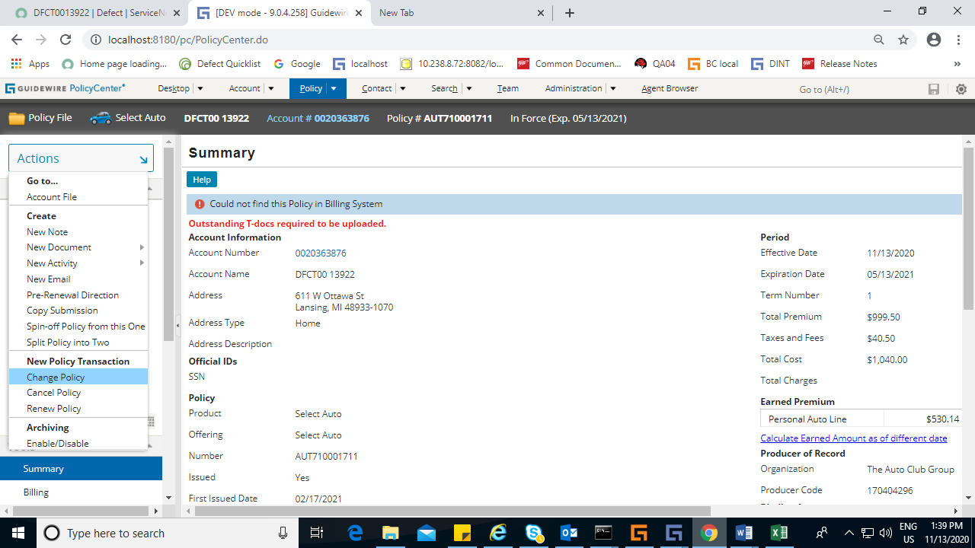

Change the address to new address

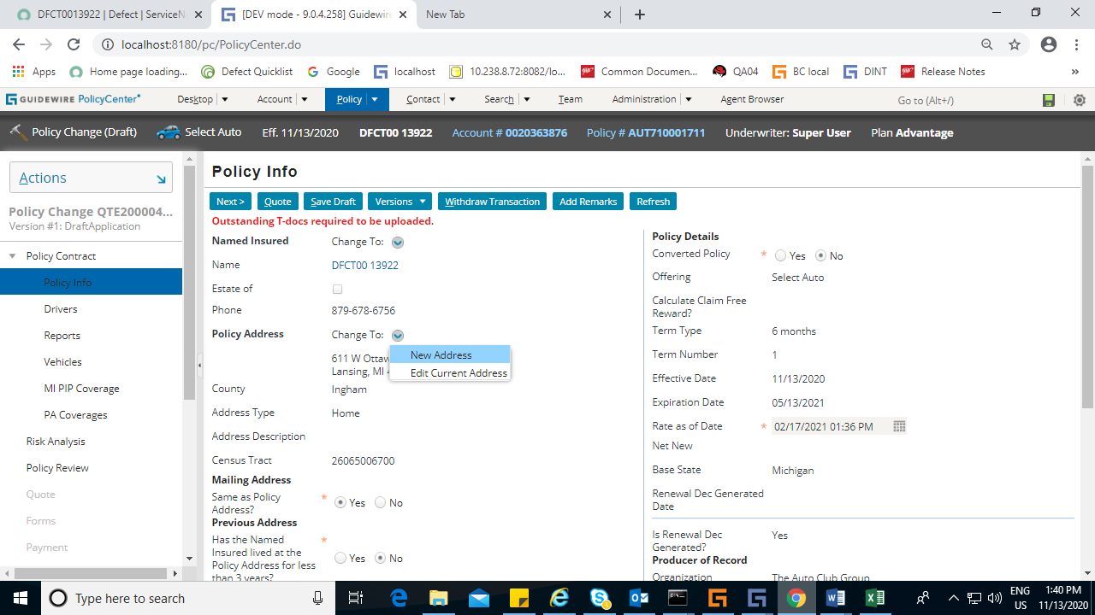

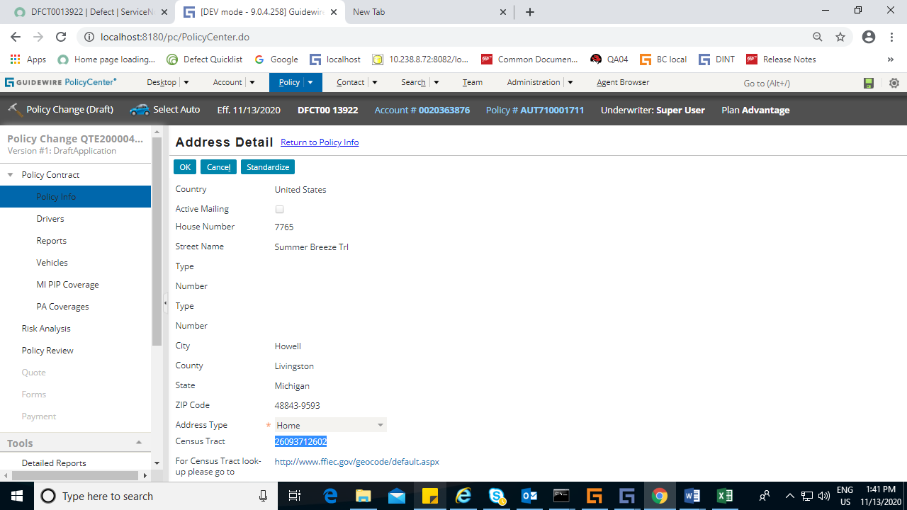

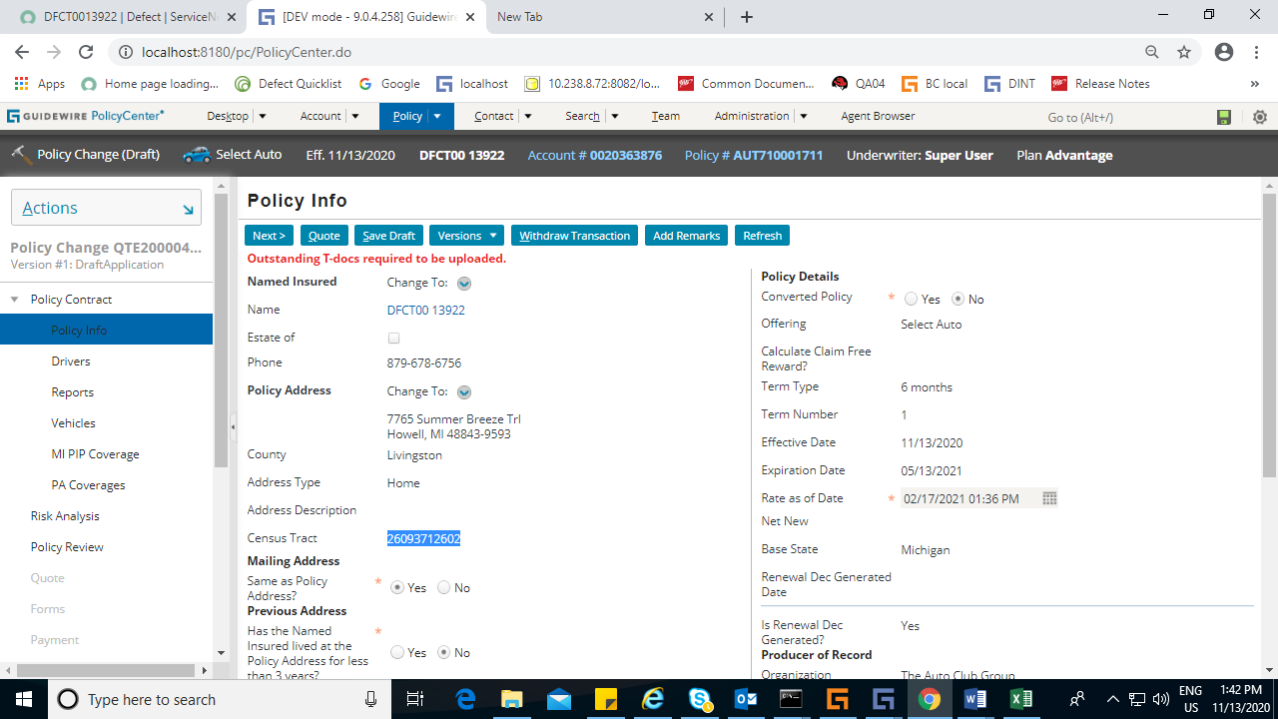

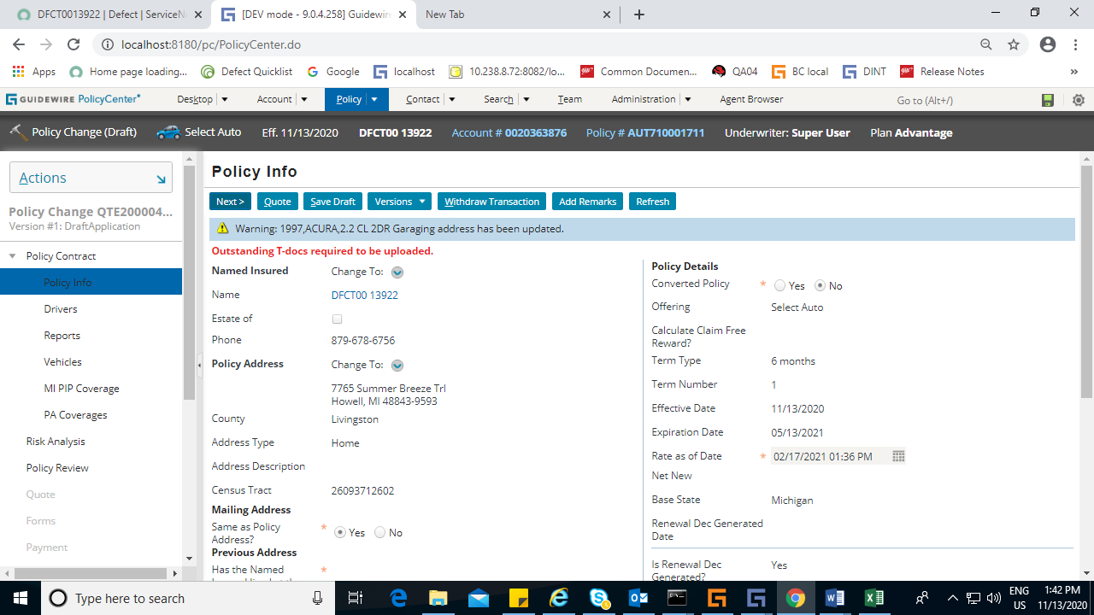

Garage also got updated

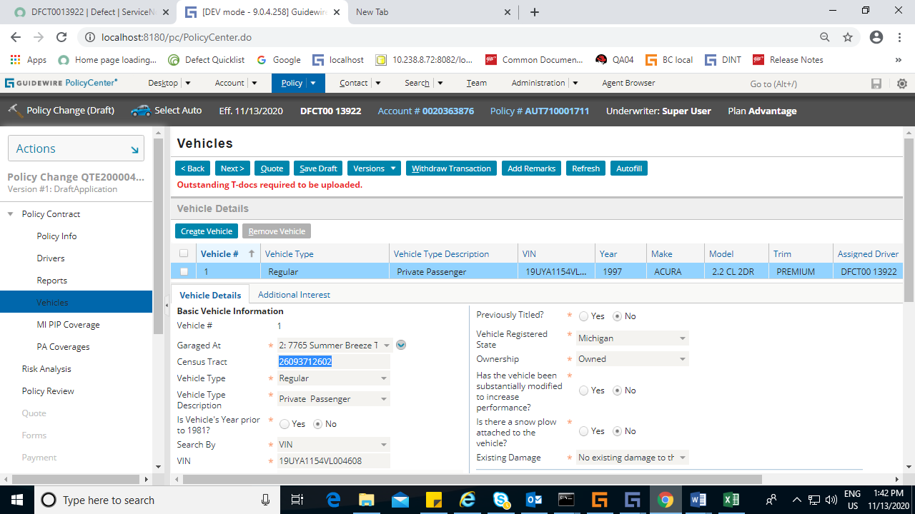

Quoted the transaction

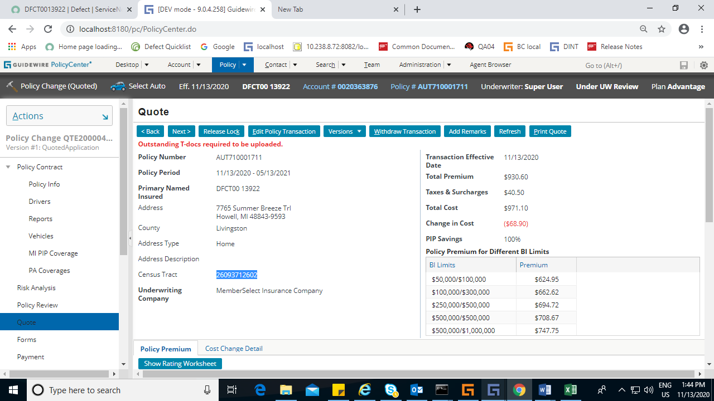

Withdrawn the transaction

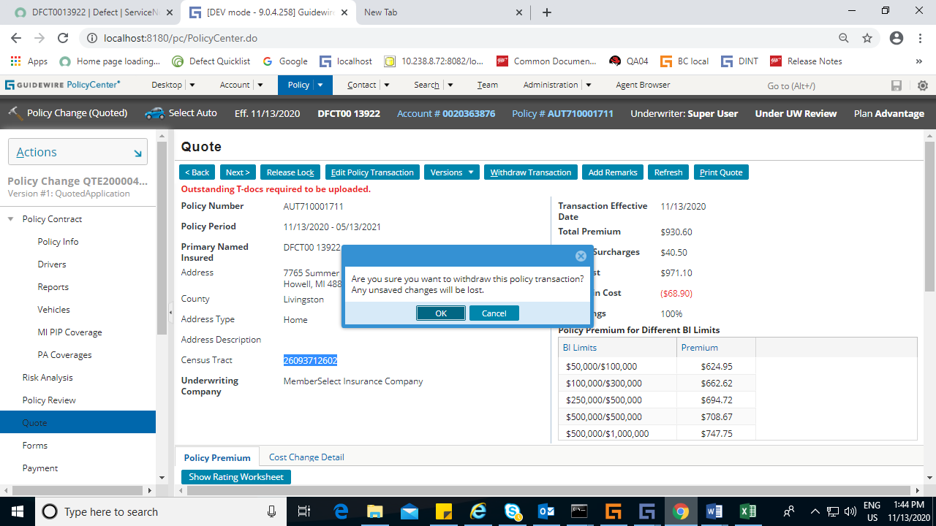

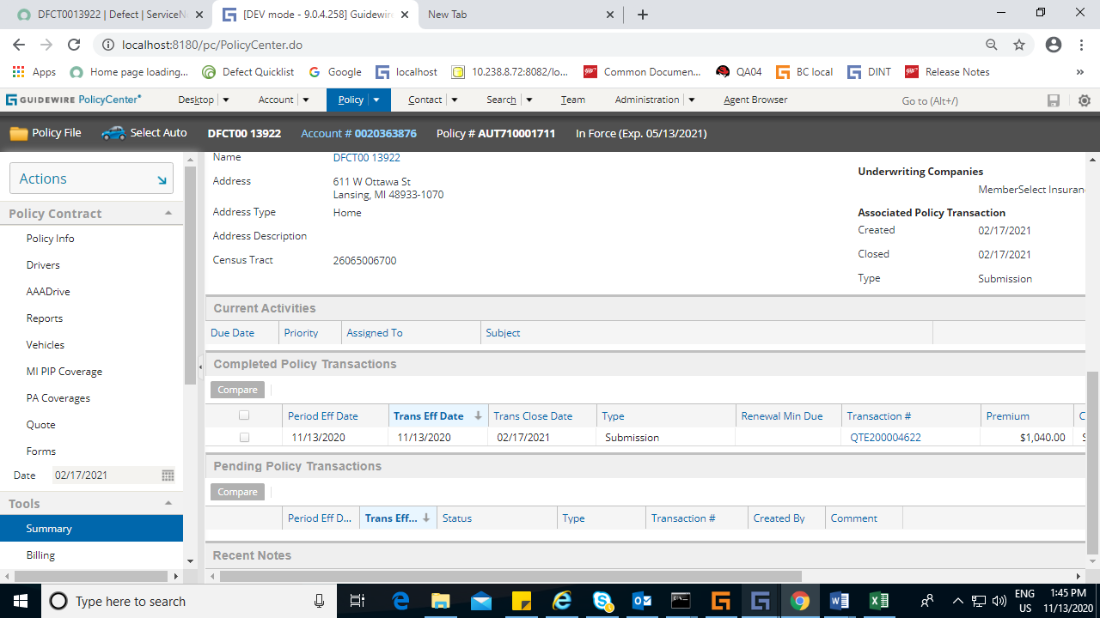

Verified in submission transaction and census tract is not changed

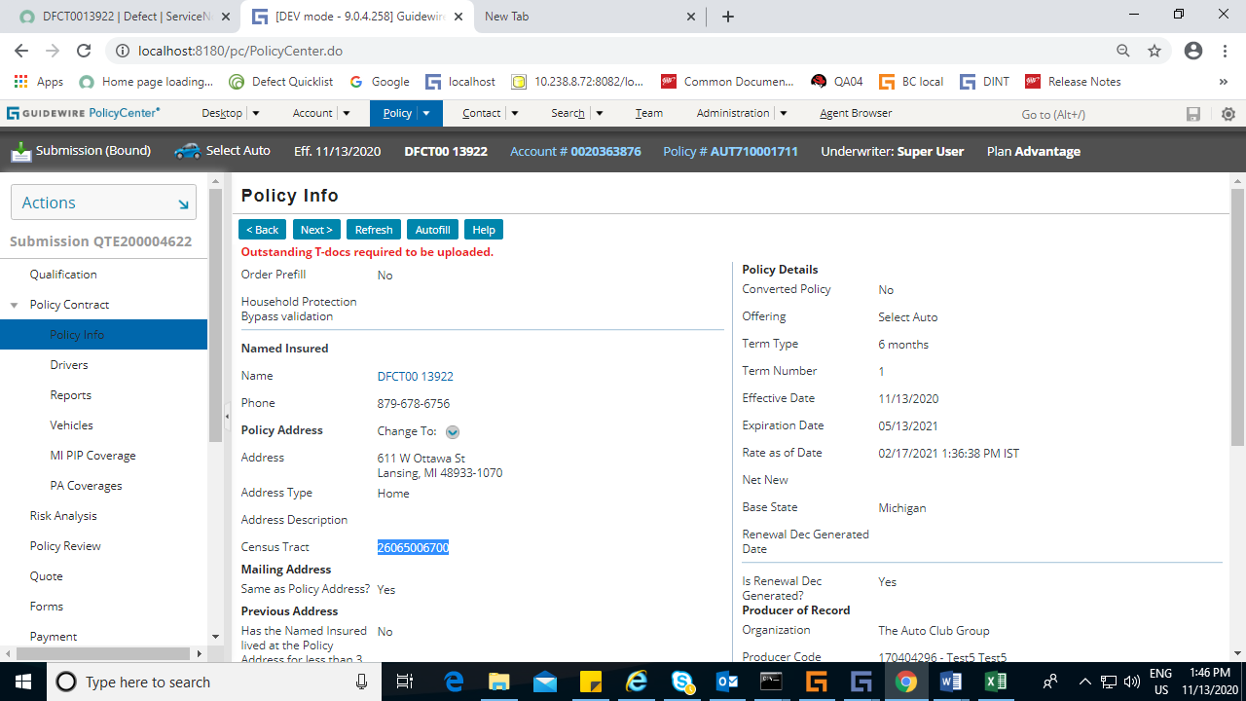

In vehicle screen

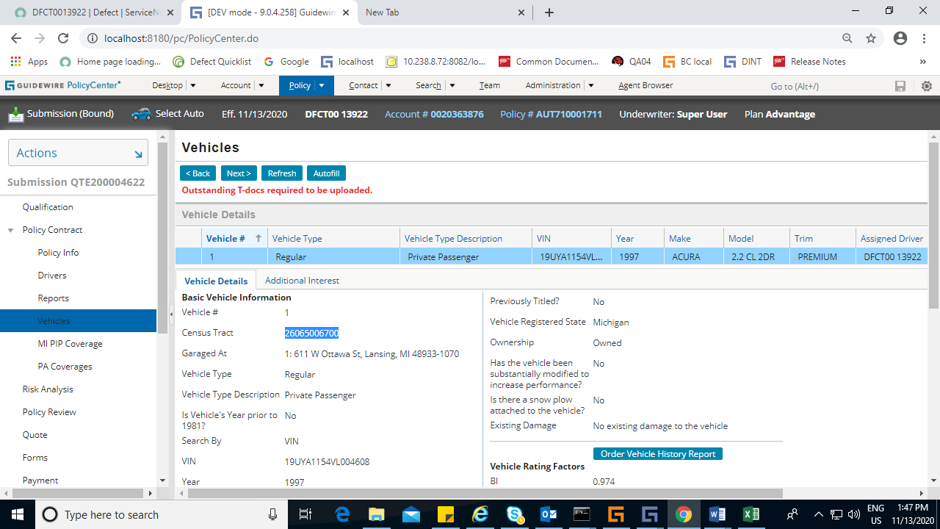

In quote screen

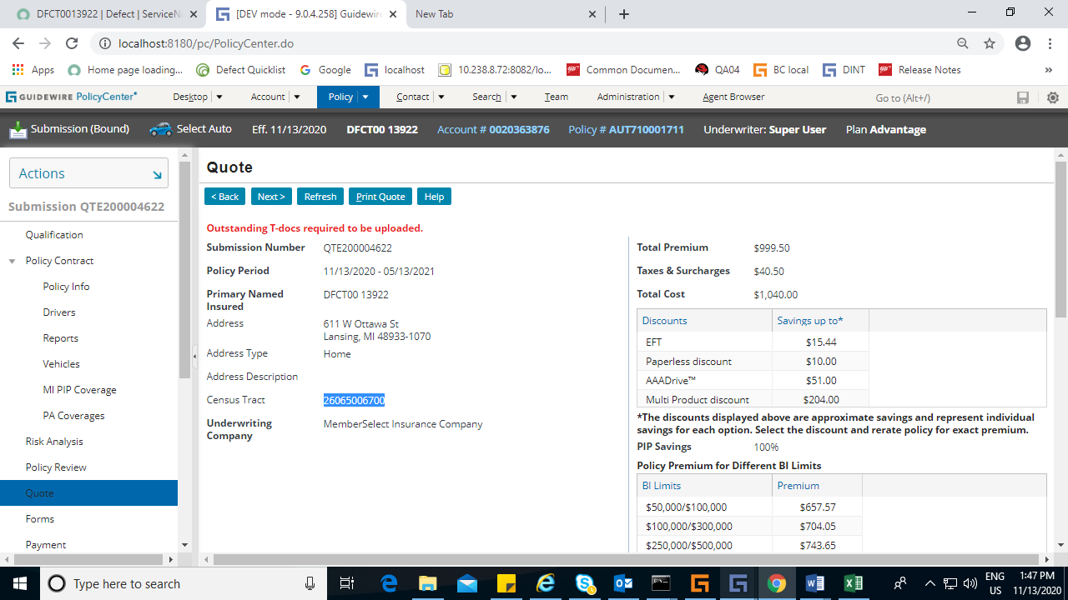

Initiated one more policy change

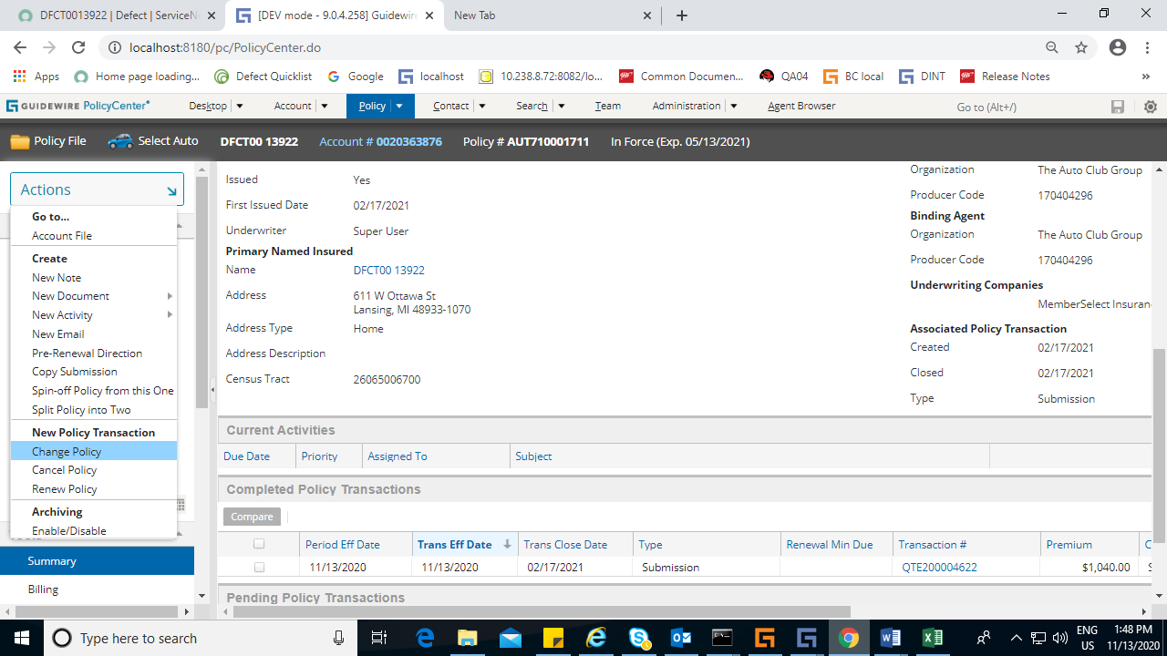

Even in subsequent policy change transaction census tract did not change

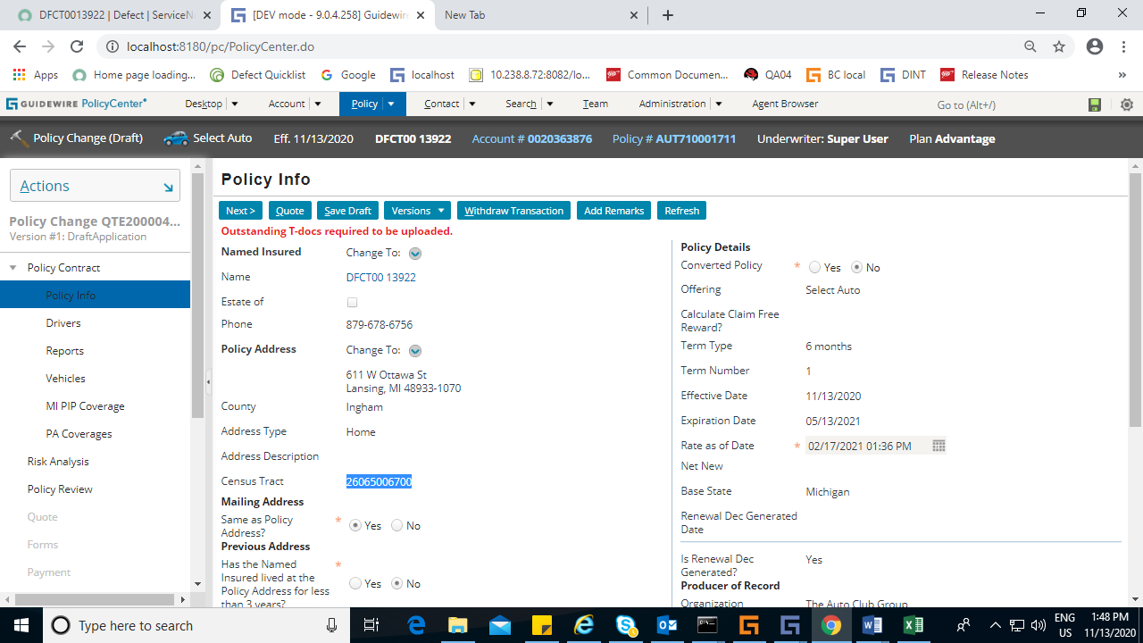

In vehicle screen

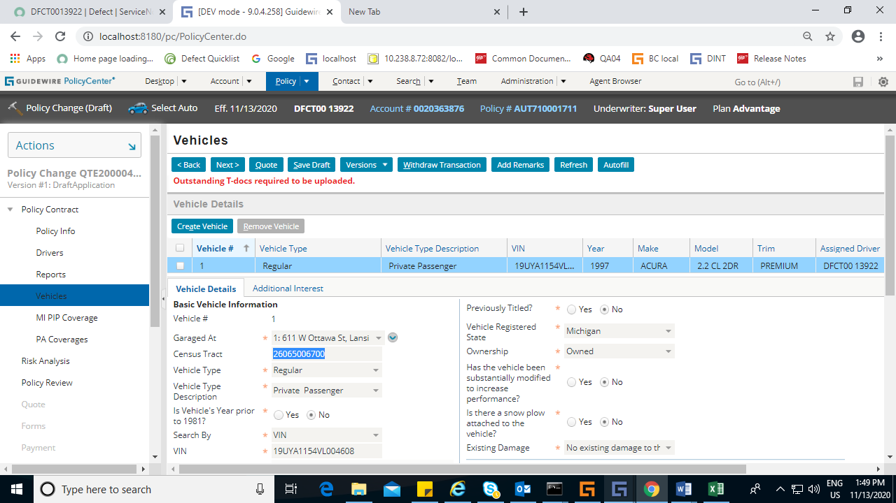

Quoted the transaction

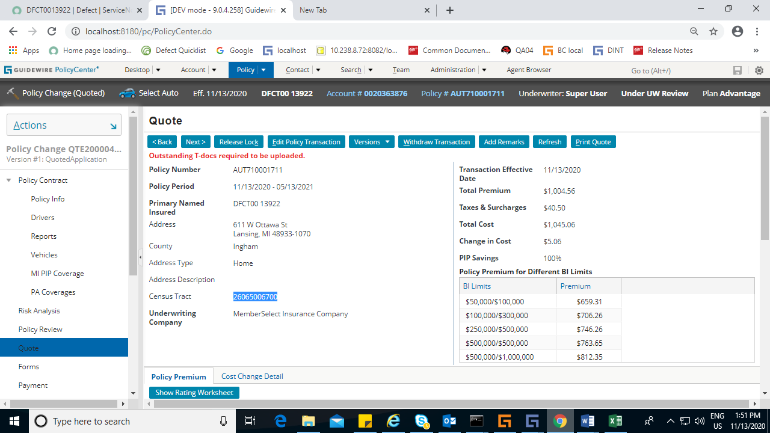

DFCT0014408

When changing the list bill contact in policy change ,the payments screen still has the old additional interest.

Steps to replicate :

1.Submission- MOR 1 with additional interest as ABC

2.Trigger a systematic policy change to change the plan from list bill to direct bill due to NO payment.

3.Tigger as systematic policy cancellation from BC.

4. Move clock to +1 day Reinstate the policy.(Reinstate without gap)

5.On the same day perform policy change effective same date- remove the perivious addtional interest and add a new on.

Post this in the payments screen the list bill contact will be the old one itself,Trying to change to new will throw a invalid server response error .When we bind the policy (With old additional interest itself) then it gets stuck in queue .